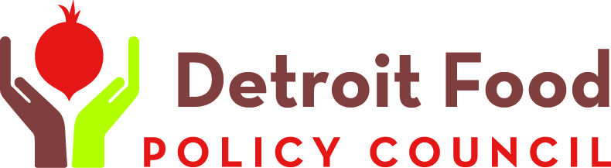
Contact Kibibi Blount-Dorn  Telephone 313-833-0396  Cell 313-477-3748  Email kibibi@detroitfoodpc.org  Website detroitfoodpolicycouncil.net | FOR IMMEDIATE RELEASE  August 26, 2016

DFPC ANNOUNCES GOLDEN BEET AWARD WINNERS

Second annual event celebrates individuals and groups working for a better food system
DETROIT, MI, August 26, 2016– Join the Detroit Food Policy Council as it celebrates good food and the people who create it at the second annual Golden Beet Awards. The gala and awards ceremony is Thursday, Sept. 22 at the Loft at 1420 Washington.
Award winners to be recognized at the event are:
Akello Karamoko
Brother Nature Farms
Binder Street Block Club
Doriawn Rogers
“The Golden Beet Awards provide us an opportunity to celebrate all the great things going on around building a sustainable, healthy, local food system in Detroit, and to honor the people who are making them happen,” says Detroit Food Policy Council Program Manager Kibibi Blount-Dorn.
Tickets for the event are $100 for VIP participants, which include a Good Food Tour of Detroit markets, gardens, and businesses involved in building a healthy food system in Detroit. Regular tickets are $50 and include a strolling supper and the awards ceremony. Proceeds from the event will fund DFPC’s work in education, engagement, research, policy and youth programming.
The Detroit Food Policy Council is an education, advocacy and policy organization led by Detroiters committed to creating a sustainable local food system that promotes food security, food justice and food sovereignty in the City of Detroit.
# # #
If you would like more information about this topic, please contact Kibibi Blount-Dorn at 313-833-0396 or email at kibibi@detroitfoodpc.org.

