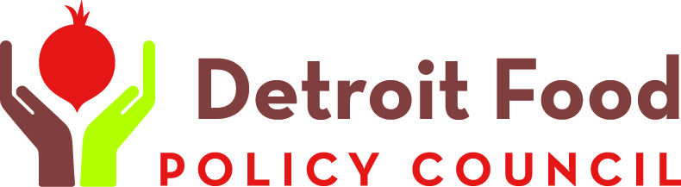
Contact Winona Bynum  Telephone 313-833-0396  Email winona@detroitfoodpc.org  Website Detroitfoodpc.org | FOR IMMEDIATE RELEASE  February 16, 2017

Detroit FOod summit 2017 features thought leaders

7th annual gathering features workshops, speakers and discussions touching every aspect of the food system

Detroit, MI, February 16, 2017–The Detroit Food Policy Council is preparing to host its 7th annual Detroit Food Summit. This year’s event, titled “Come Together” will draw hundreds of people engaged in the work of building a better food system. The event will be March 9-10 at the Benson and Edith Ford Conference Center at the A Alfred Taubman Center for Design Education, 460 W. Baltimore Ave, Detroit, MI 48202.
Mary Lee of Los Angeles research and action institute PolicyLink will headline the two-day gathering with a keynote speech March 10. Lee is a member of the L.A. Food Policy Council and a practicing attorney with more than 30 years of experience working in communities throughout California, with special emphasis on issues of housing, land use and community economic development. Her work has always focused on the legal rights of low-income people.
On March 9, Dr. Kami Pothukuchi will speak on the State of the Food System. Dr. Pothukuchi is associate professor and chair of the Department of Urban Studies and Planning at Wayne State University; founding director of SEED Wayne; and a founding member of the Detroit Food Policy Council. Dr. Pothukuchi’s research and professional activities have helped create the sub-field of food planning within the broader field of urban planning.
Other sessions will focus on national and state food policy; a panel of local leaders discussing the Detroit food system, and a plethora of workshops covering everything from kidney health to climate’s impact on urban agriculture. A film screening of Sugar Babies will be held Thursday evening, as well.

DETAILS:
Thursday, March 9, 8:30 am - 5:00 pm
Friday, March 10, 9:00 am - 3:00 pm
What About Food? Film Screening and Dialogue
Film: Sugar Babies
Thursday, March 9, 5:30 - 8:00 pm

Benson and Edith Ford Conference Center
Alfred A. Taubman Center for Design Education, College for Creative Studies
460 W. Baltimore Ave, Detroit, MI 48202
COST: $25 youth, $55 student/senior, $110 Early bird (expires Feb. 17), $125-$150.
WEBSITE: http://detroitfoodpolicycouncil.net/events/detroit-food-2017
The Detroit Food Policy Council was established in 2009 by unanimous approval of The Detroit City Council. The DFPC is an implementation, monitoring and advisory body and consists of twenty-one members, including thirteen (13) representatives from various sectors of the Food System, four (4) "at-large" representatives, one (1) youth representative and three (3) governmental representatives, one each from the Mayor's Office, City Council and The Department of Health and Wellness Promotion (DHWP).
DFPC is committed to nurturing the development and maintenance of a sustainable, localized food system and a food-secure City of Detroit in which all of its residents are hunger-free, healthy, and benefit economically from the food system that impacts their lives.

# # #
If you would like more information about this topic, please contact Winona Bynum at 313-833-0396 or email at winona@detroitfoodpc.org.

